**Science_Q_tech Employee Performance Mapping**

1. Create a database named *employee*, then import **data_science_team.csv proj_table.csv** and **emp_record_table.csv** into the **employee** database from the given resources.

create database employee;

use employee;

alter table emp_record_table

modify column emp_id varchar(20);

alter table emp_record_table

add primary key(emp_id);

alter table proj_table

modify column project_id varchar(20);

alter table proj_table

add primary key(project_id);

select * from emp_record_table ;

update emp_record_table

set proj_id=null

where proj_id='NA';

alter table emp_record_table

modify column proj_id varchar(20);

alter table emp_record_table

add foreign key(proj_id) references proj_table(project_id);

alter table data_science_team

modify column emp_id varchar(20);

alter table data_science_team

add foreign key(emp_id) references emp_record_table(emp_id);

1. Create an ER diagram for the given **employee** database.

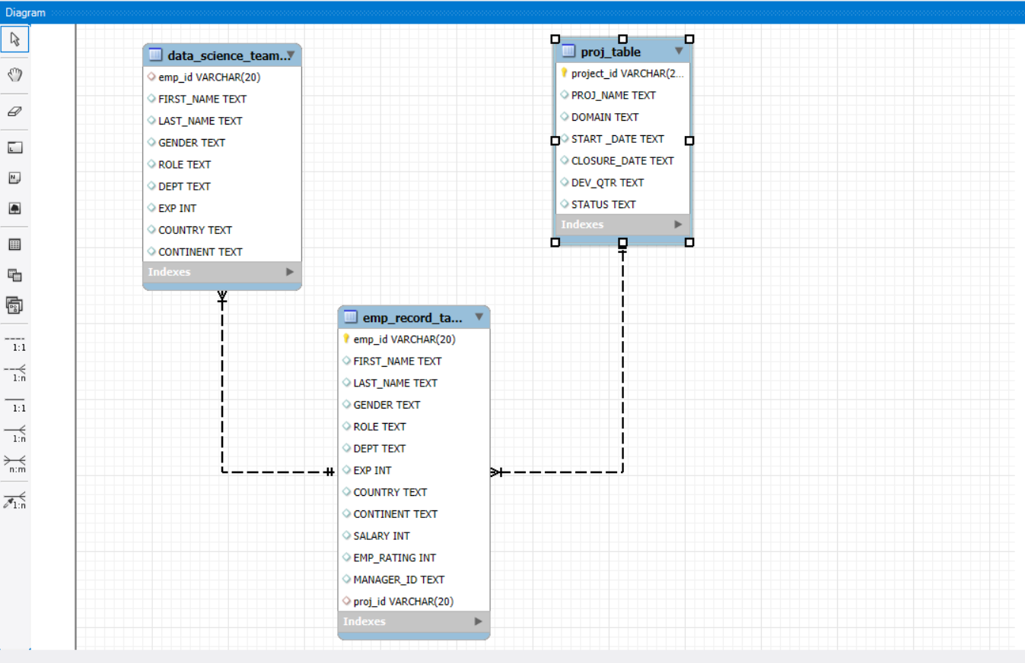

1. Write a query to fetch EMP_ID, FIRST_NAME, LAST_NAME, GENDER, and DEPARTMENT from the employee record table, andmake a list of employees and details of their department.

SELECT emp_id,first_name,last_name,gender,dept from emp_record_table;

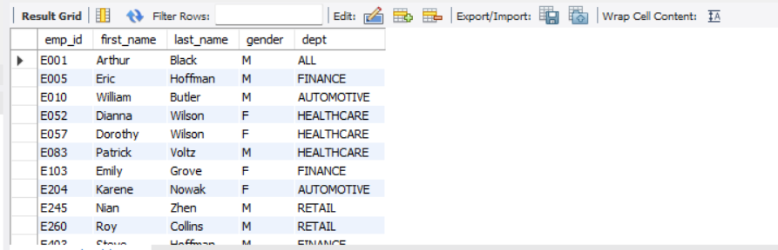

1. Write a query to fetch EMP_ID, FIRST_NAME, LAST_NAME, GENDER, DEPARTMENT, and EMP_RATING if the EMP_RATING is:

* less than two
* greater than four
* between two and four

SELECT emp_id,first_name,last_name,gender,dept,emp_rating from emp_record_table

where emp_rating between 2 and 4;

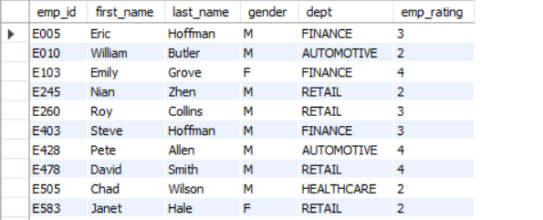

SELECT emp_id,first_name,last_name,gender,dept,emp_rating from emp_record_table

where emp_rating <2;

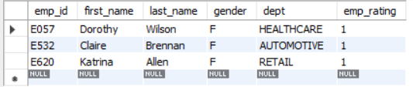

SELECT emp_id,first_name,last_name,gender,dept,emp_rating from emp_record_table

where emp_rating >4;

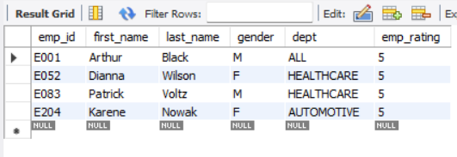

1. Write a query to concatenate the FIRST_NAME and the LAST_NAME of employees in the *Finance* department from the employee table and then give the resultant column alias as NAME.

select concat(first_name, ' ', last_name) AS Names from emp_record_table

where dept='Finance';

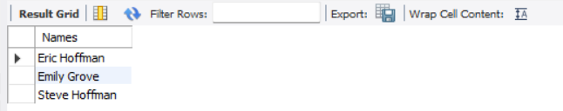

1. Write a query to list only those employees who have someone reporting to them. Also, show the number of reporters (including the President).

select concat(first_name, ' ',last_name) as ENAme, cnt from emp_record_table as t1

inner join

(select manager_id, count(*) as cnt from emp_record_table

group by manager_id) as t2

on t1.emp_id=t2.manager_id

;

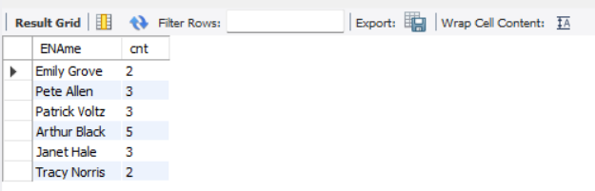

1. Write a query to list down all the employees from the healthcare and finance departments using union. Take data from the employee record table.

select * from emp_record_table where dept='Finance'

union

select * from emp_record_table where dept='HealthCare';

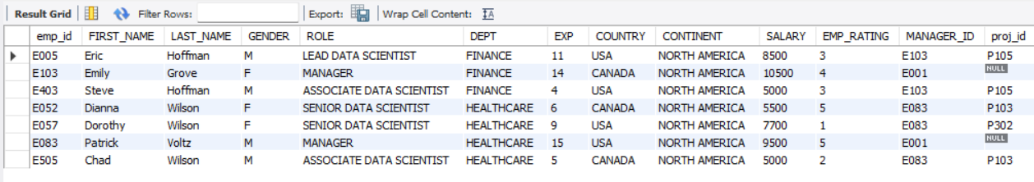

1. Write a query to list down employee details such as EMP_ID, FIRST_NAME, LAST_NAME, ROLE, DEPARTMENT, and EMP_RATING grouped by dept. Also include the respective employee rating along with the max emp rating for the department.

select *, max(emp_rating) over(partition by dept order by emp_rating desc)

from emp_record_table;

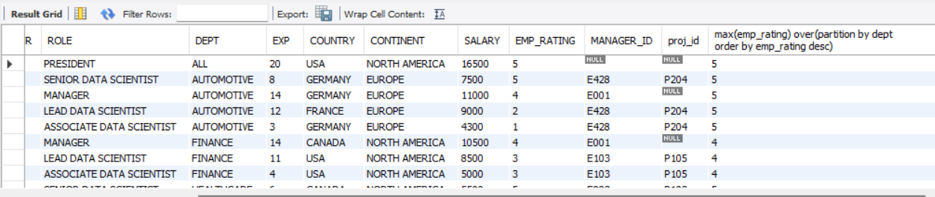

1. Write a query to calculate the minimum and the maximum salary of the employees in each role. Take data from the employee record table.

select role,

MIN(salary) as minimum_salary,

MAX(salary) as maximum_salary

from emp_record_table

group by role;

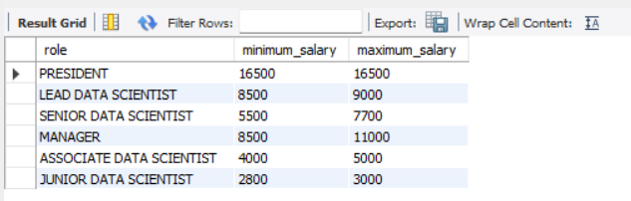

1. Write a query to assign ranks to each employee based on their experience. Take data from the employee record table.

select concat(first_name, ' ',last_name) as ENAme, exp, rank() over (order by exp desc) as experience_rank

from emp_record_table;

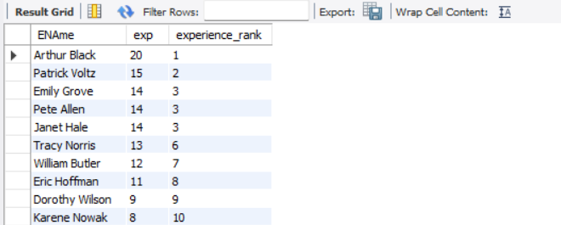

1. Write a query to create a view that displays employees in various countries whose salary is more than six thousand**.** Take data from the employee record table.

CREATE VIEW EMPLOYEES_BY_COUNTRY

AS

select salary, first_name, country from emp_record_table

WHERE SALARY > 6000;

select * from EMPLOYEES_BY_COUNTRY;

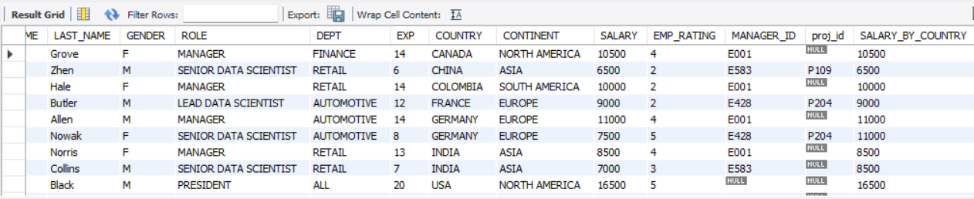

1. Write a nested query to find employees with experience of more than ten years. Take data from the employee record table.

select * from (

select * from emp_record_table

where exp>10) as t;

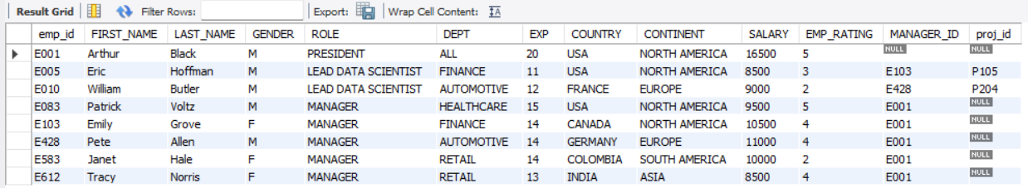

1. Write a query to create a stored procedure to retrieve the details of the employees whose experience is more than three years. Take data from the employee record table.

delimiter //

create procedure sp_high_exp_emps()

begin

select * from emp_record_table where exp > 3;

end //

delimiter;

call sp_high_exp_emps;

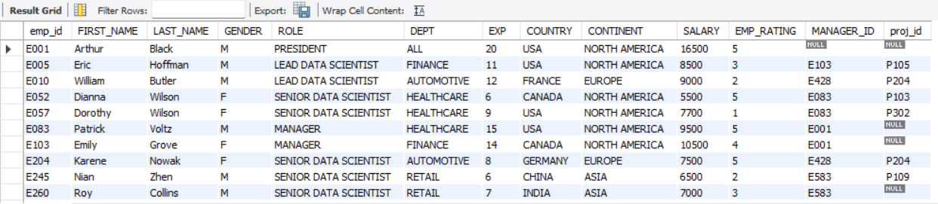

1. Write a query using stored functions in the project table to check whether the job profile assigned to each employee in the data science team matches the organization’s set standard.

select * , case

when exp <=2 then 'JUNIOR DATA SCIENTIST'

when exp <=5 then 'ASSOCIATE DATA SCIENTIST'

when exp <=10 then 'SENIOR DATA SCIENTIST'

when exp <=12 then 'LEAD DATA SCIENTIST'

when exp <=16 then 'MANAGER'

end as task from emp_record_table;

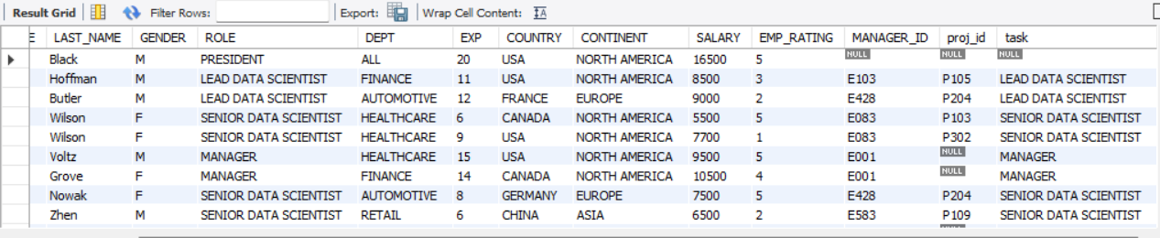

1. Create an index to improve the cost and performance of the query to find the employee whose FIRST_NAME is ‘Eric’ in the employee table after checking the execution plan.

alter table emp_record_table

modify column FIRST_NAME varchar(20);

create index ix_fname on emp_record_table(first_name);

1. Write a query to calculate the bonus for all the employees, based on their ratings and salaries (Use the formula: 5% of salary * employee rating).

select *, salary*0.05 as bonus from emp_record_table;

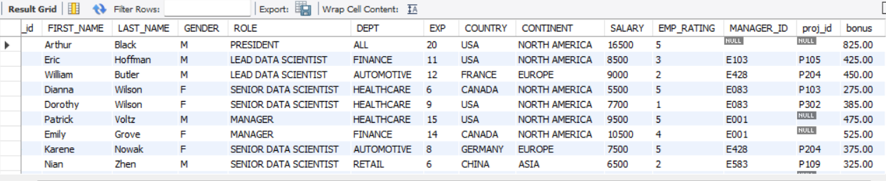

1. Write a query to calculate the average salary distribution based on the continent and country. Take data from the employee record table.

select continent,country, avg(salary) AS Avg from emp_record_table

group by continent ,country;

